**5SENG007W Software Engineering Principles and Practice**

**Week 3 Seminar**

**Task 1**

You have already decided the “Theme” for your coursework.

Identify Stakeholders for your scenario.

Please them in an Onion model.

You can use pen and paper for this task.

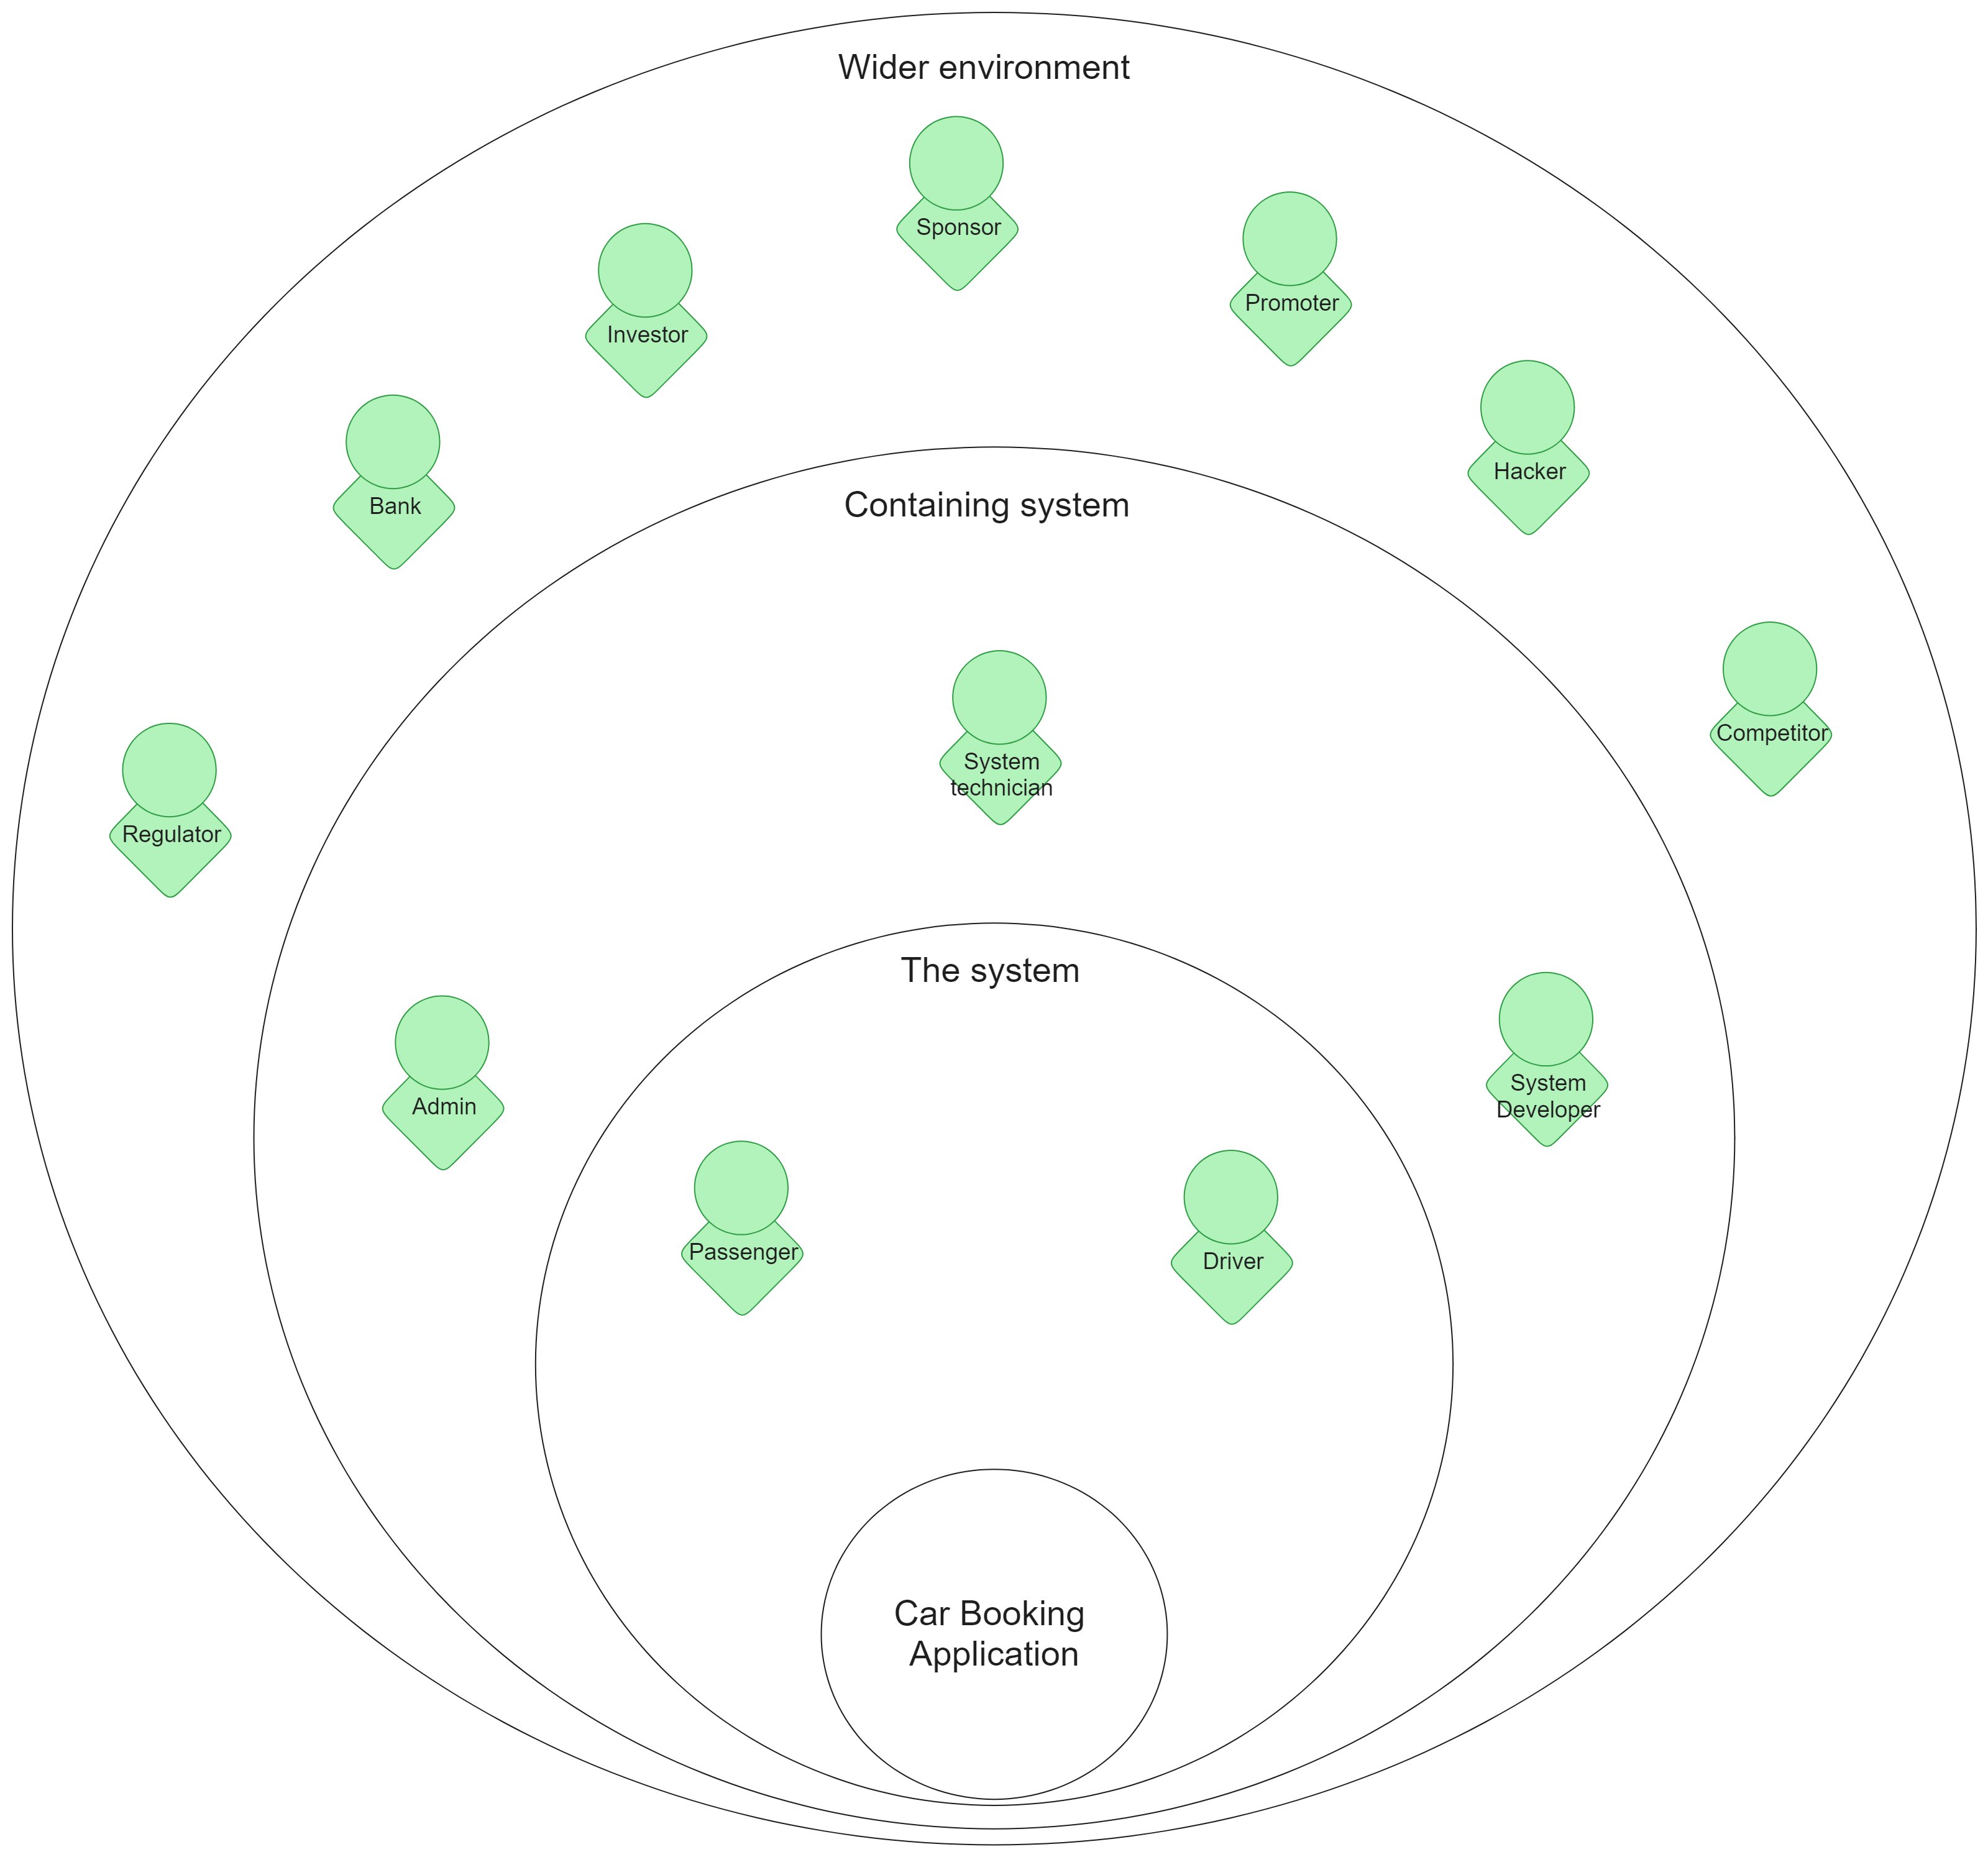

**Task 2**

Devise a 1 to 1 Interview for one of the stakeholders in the diagram.

You would need to formulate THREE questions to ask a Stakeholder.

Your Stakeholder would be the Tutor.

Document the findings – you would need to use it for your coursework.

1. Who are the primary users of the system?
2. What do you want the primary users to be able to do?
3. What security concerns do you have about the application